Chapter 3 p.51

Most targeted regions

A breakdown of operations by region reflects the priority targets of the threat actors. Ukraine is the top European target per volume of observed activity, driven by Russian state actors’ invasion-related operations. Israel remains by far the most-targeted country in the Middle East and North Africa region as a result of Iran’s extensive focus there. North Korean and Chinese state actors drove South Korea and Taiwan to the first and second most targeted geographies in the Asia-Pacific

Pie chart showing percentages of the most targeted regions in Europe. It shows A. Ukraine: 33%, B. United Kingdom: 11%, C. France: 5%, D. Poland: 5%, E. Italy: 4%, F. Germany: 3%, G. Switzerland: 3%, H. Netherlands: 3%, I. Azerbaijan: 2%, J. Albania: 2%, and K. Other: 29%.

Pie chart showing percentages of the most targeted regions in Middle East and North Africa. It shows A. Israel: 38%, B. United Arab Emirates: 12%, C. Saudi Arabia: 9%, D. Jordan: 6%, E. Iraq: 5%, F. Bahrain: 4%, G. Lebanon: 4%, H. Egypt: 4%, I. Türkiye: 4%, and J. Other: 14%.

Pie chart showing percentages of the most targeted regions in Asia-Pacific. It shows A. Korea: 17%, B. Taiwan: 15%, C. India: 13%, D. Malaysia: 6%, E. Japan: 5%, F. Australia: 4%, G. Thailand: 5%, H. Indonesia: 5%, I. Pakistan: 4%, J. Philippines: 4%. K. Other: 21%.

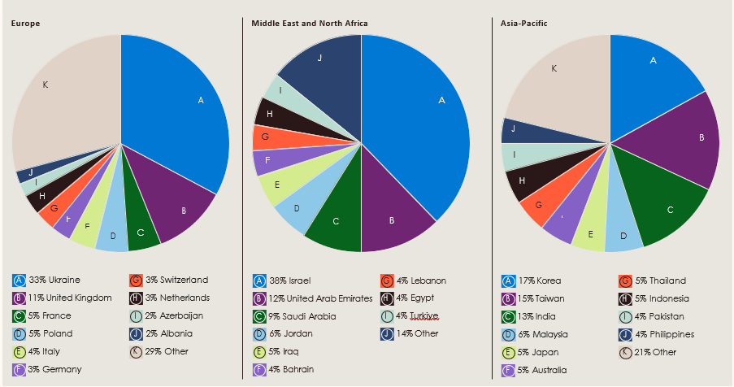Source: Microsoft Threat Intelligence events data